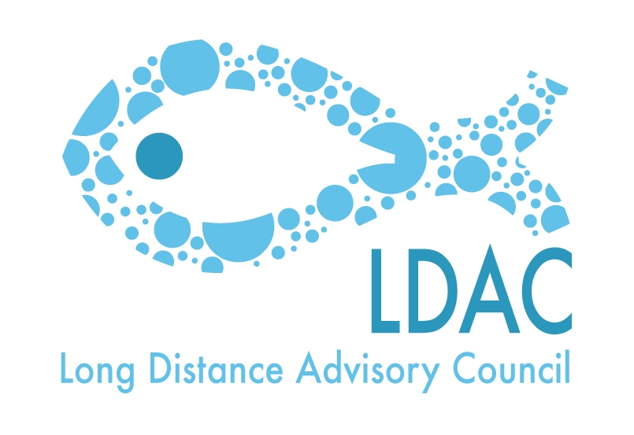
AGENDA
17th Meeting of Working Group 4

Bilateral relations with third countries

Wednesday 21 October 2015. From 09h30 till 13:30h

Martin’s Central Park Hotel
Boulevard de Charlemagne 80.Brussels

- Welcome.
- Approval of the minutes of the last WG4 meeting – Brussels, 10 March 2015.
- Approval of the Agenda.

- Update of the last negotiations and meetings held by the European Commission relating the agreements with third countries or regions.
  - Agreements in West Africa. (Morocco, Mauritania, Cape Verde, Senegal, Guinea Bissau, Republic of Guinea, Liberia…)
  - Agreements in Indian Ocean (Mozambique, Tanzania, Kenya, Madagascar…)
  - Agreements in Pacific Ocean (Kiribati, Cook Islands…)

- Horizontal Issues.
  - Report on the implementation of the 3rd Countries re the IUU regulation.
  - Role of the LDAC in Regional projects: collaboration.
    - Indian Ocean: Smartfish Project
    - Atlantic Ocean: ATLAFCO-COMHAFAT

- AOB.
- Place and date of the next meeting.
- Closure.

