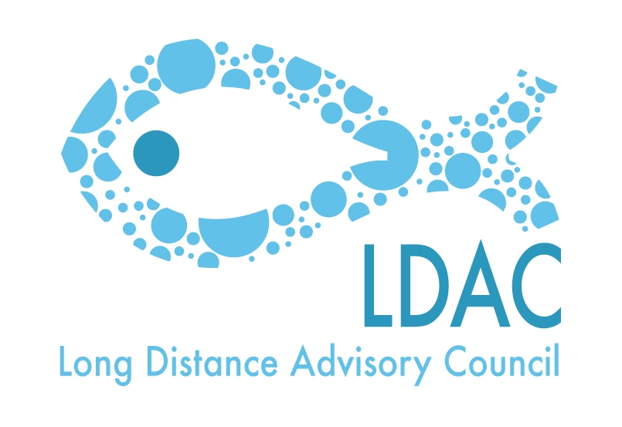
Draft agenda of the
15th Working Group 5 Meeting of LDAC
Horizontal issues

Tuesday the 14 of October of 2014. From 14:00h till 18:30h
Martin’s Central Park Hotel
Boulevard de Charlemagne 80.Brussels

- Reading and approval of the minutes of the 14th WG5 meeting from the 21st of March 2014.
- Approval of the agenda.
- Current negotiations or negotations in preparation:
3.1. Negotiations on bilateral agreements (Ecuador, Thailand…)
3.2. Other current negotiations
3.3. TTIP negotiations (access to the fishing areas for the fleet).
4- New GSP Regulation: Beneficiary countries. Update on the possible integration of the Philippines in the GSP+ for the tuna industry.
5- State of play of the EPA with ACP countries; and to the negotiations of the complete EPA Agreements.
- News about the negotiations withing the WTO.
- Application of new discards policy (meeting September 2014, Brussels)
- UN meeting (September 2014)
- Seminar with MS on the main aspects of the external dimension of the new CFP.
- AOB
- Date and place of next meeting.
- Closure.

