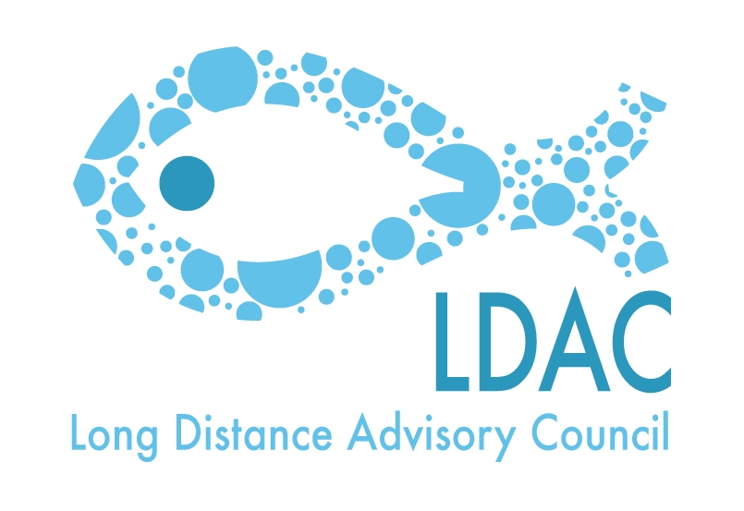
Agenda
16th Working Group 4 meeting of the LDAC

Bilateral relations with third countries

Tuesday 10 March 2015. From 09h30 till 13:30h

Martin’s Central Park Hotel
Boulevard de Charlemagne 80.Brussels

- Welcome.

- Approval of the minutes of 15th WG4 meeting held on the 15th of October of 2014.

- Approval of the Agenda.

- Update of the last negotiations and meetings maintained by the EC relating the agreements with third countries or regions.
  - Agreements in West Africa. (Morocco, Mauritania, , Senegal, G. Bissau, Republic of Guinea, Cape Verde, Liberia, …)
  - Agreements in the Indian Ocean (Mozambique, Tanzania, Kenya, Madagascar)

- Horizontal issues.
  - Report on the implementation of the Third Countries regarding the IUU regulation.
  - Participation between LDAC and STECF.

- AOB.
- Place and date of the next meeting.
- Closure.

